21/03/24
THM 415: Finance
Midterm Exam Answer Sheet
- “Format wise, current assets are sorted in a way that cash is followed by marketable securities, then comes accounts receivables followed by inventories and, lastly, we have other current assets”. Do you agree with this order? Why? Why not? (2 Points)
Yes, I agree with this order and the reason is that current asset accounts are sorted in the balance sheet according to how liquid it is (i.e. according to the speed within which it can converted into cash without loss of value).
- Muleka Hotel had recorded the following income statement accounts sorted in alphabetical order:
Cost of Goods Sold | $2,546,802
Interest Expenses | $257,257
Operating Expenses | $817,453
Sales | $5,256,963
In addition, since Muleka Hotel owns 43 % shares of Jackson Company, it is entitled to $ 1,500,750 of dividends income from that very company. Moreover, Muleka hotel’s board of directors decided to distribute $ 250,000 as dividends to their shareholders.
The following table reveals Income Tax Rates for Corporate Income for 2023 fiscal year:
Taxable Income | Marginal Tax Rate
$ 0 – $ 100,000 | 15%
$ 100,001 - $200,000 | 17%
$ 200,001 - $ 400,000 | 19%
$ 400,001 - $ 575,000 | 21%
$ 575,001 - $ 900,000 | 23%
$ 900,001 - $ 1,500,000 | 25%
Over $ 1,500,000 | 33%
Lastly, the following table shows dividend income exclusion to avoid double taxation at corporate level.
Ownership Interest | Dividend Exclusion
Less than 20 % | 18%
20 % to 35 % | 28%
35 % to 55 % | 38%
55 % to 75 % | 58%
75 % to 85 % | 78%
More than 85 % | 100%
a) Construct Muleka Hotel Income Statement for the year ended December 31st, 2023. (2 Points)
Moreover, the following is Muleka Hotel’s comparative balance sheet as of December 31st, 2022 and December 31st, 2023:
- Construct Muleka Hotel Statement of Cash Flow for the year ended December 31st, 2023. (3 Points)
- Calculate the Quality of Earnings. Interpret your result. (1 Point)
- Quality of Earnings = (Cash Flow from Operations) / (Net Income) = 883,588 / 952,199 = 92.79 %.
Thus, in 2023, Muleka Hotel’s cash flow from operations was 92.79 % of the firm’s reported net income.
- Calculate the Capital Acquisition Ratio. Interpret your result. (1 Point)
- Capital Acquisition Ratio = (Cash Flow from Operations) / (Cash Paid for Capital Expenditures) = 883,588 / 132,673 = 665.99 %.
Thus, in 2023, Muleka Hotel generated, from its operations, cash flow that is able to finance more than 6 times of its new expenditures for plant and equipment.
- Based on the income statement prepared in part a), comparative balance sheet and cash flow statement prepared in part b), analyze the financial situation of Muleka Hotel for the fiscal year 2023. (3 Points)
Income Statement:
- In 2023, Muleka hotel is a profitable company as its revenues (i.e. sales) are greater than its costs.
- In 2023, Muleka Hotel’s mark-up on its cost of goods sold is 51.55 %.
- In 2023, for each dollar of revenue, Muleka Hotel is left with 36 cents after deducting all its operating expenses.
- In 2023, each one dollar of sales is associated with 18.11 cents of net income.
Balance Sheet:
- Muleka hotel is a highly liquid company as its net working capital is $ 1,212,893. This means that current assets can shrink by as much as $ 1,212,893 and the company would still be able to pay its current liabilities.
- In Muleka Hotel, the purchases of assets are financed 36.73 % through debt and 63.27 % through equity.
- For each one dollar of net income, 73.74 cents are retained in the business.
Statement of Cash Flow:
Cash flow from operating activities:
- Muleka Hotel has positive cash flow from operating activities.
- The primary contributors to the operating cash flows were net income, accounts receivables and depreciation expense.
- Inventories, accounts payable and accrued expenses are the contributors of cash usage.
Cash flow from investing activities:
- Muleka Hotel invested $ 132,673 in purchasing fixed assets. This represents 15.02 % of the total cash flow generated from operations.
Cash flow from financing activities:
- Muleka Hotel has negative cash flow from financing activities.
- Cash usage resulted from payment of already declared dividends, purchase of marketable securities as well as payment of short-term notes.
- The contributors to cash were the issuance common stock (par), getting a long-term note and common stock (paid-in-capital).
- Suppose you would like to triple your investment. For this purpose, you deposited in a bank $ 23,534.92 to be compounded monthly at an interest rate of 5.06 %. Calculate the period (in years) needed to reach your objective? (1 Point)
- Interest Rate = 5.06 % / 12 = 0.42166 %; Present Value = - $ 23,534.92; Payment = $0; Future Value = $ 70,604.76.
Answer: Nper (0.42166 %, 0, -23534.92, 70604.76) / 12 = 21.76 Years.
Therefore, it would take 21.76 years for an investment of $ 23,534.92 to triple at an annual interest rate of 5.06 % compounded monthly.
- After examining the various interest rates opportunities, you find that you can borrow from a finance company at 9.03 % compounded monthly, from bank A at 9.00 % compounded weekly.
a) Which alternative is the most attractive? Why? (1 Point)
- Borrowing from Finance Company: Effective Annual Rate= Effect (9.03 %, 12) = 9.41 %.
- Borrowing from bank A: Effective Annual Rate = Effect (9 %, 52) = 9.41 %.
Since I am borrowing, I shall choose the offer that has the lowest Effective Annual Rate. Therefore, I shall borrow from Bank A (9.4089 % for Bank A vs. 9.4133 % for Finance Company).
b) If you wanted to consider Bank B which offers continuous compounding. What is the maximum interest rate suggested by this very bank to start thinking about the offer? (1 Point)
Bank B shall give me a maximum rate of 8.99 % to start thinking about the offer.
- Necip wanted to buy a home that costs $ 650,000. He took a 10-year mortgage loan with semi-annual payments at an annual rate of 4.06 %.
a) How much will Necip pay each period? (1 Point)
Interest = 4.06 % / 2 = 2.03 %, Period = 10 * 2 = 20; Present Value = $ 650,000; Future Value = $ 0
Answer: Payment (2.03 %, 20, 650000, 0) = $ - 39,867.04.
b) Fill in the amortization schedule. (3 Points)
Period | Amount Owed on the Principal (Beg. Period) ($) | Annuity Payment ($) | Interest Portion of the Annuity ($) | Repayment of the Principal Portion of the Annuity ($) | Outstanding Loan Balance ($)
1 | 650,000.00 | 39,867.04 | 13,195.00 | 26,672.04 | 623,327.96
2 | 623,327.96 | 39,867.04 | 12,653.56 | 27,213.49 | 596,114.47
3 | 596,114.47 | 39,867.04 | 12,101.12 | 27,765.92 | 568,348.55
4 | 568,348.55 | 39,867.04 | 11,537.48 | 28,329.57 | 540,018.98
5 | 540,018.98 | 39,867.04 | 10,962.39 | 28,904.66 | 511,114.32
6 | 511,114.32 | 39,867.04 | 10,375.62 | 29,491.42 | 481,622.89
7 | 481,622.89 | 39,867.04 | 9,776.94 | 30,090.10 | 451,532.79
8 | 451,532.79 | 39,867.04 | 9,166.12 | 30,700.93 | 420,831.87
9 | 420,831.87 | 39,867.04 | 8,542.89 | 31,324.16 | 389,507.71
10 | 389,507.71 | 39,867.04 | 7,907.01 | 31,960.04 | 357,547.67
11 | 357,547.67 | 39,867.04 | 7,258.22 | 32,608.83 | 324,938.84
12 | 324,938.84 | 39,867.04 | 6,596.26 | 33,270.79 | 291,668.06
13 | 291,668.06 | 39,867.04 | 5,920.86 | 33,946.18 | 257,721.87
14 | 257,721.87 | 39,867.04 | 5,231.75 | 34,635.29 | 223,086.58
15 | 223,086.58 | 39,867.04 | 4,528.66 | 35,338.39 | 187,748.20
16 | 187,748.20 | 39,867.04 | 3,811.29 | 36,055.76 | 151,692.44
17 | 151,692.44 | 39,867.04 | 3,079.36 | 36,787.69 | 114,904.75
18 | 114,904.75 | 39,867.04 | 2,332.57 | 37,534.48 | 77,370.27
19 | 77,370.27 | 39,867.04 | 1,570.62 | 38,296.43 | 39,073.85
20 | 39,073.85 | 39,867.04 | 793.20 | 39,073.85 | (0.00)
c) Suppose that exactly after 6 years, mortgage interest rates fell to 3.68 %. If Necip has the chance to refinance his loan at that very interest, how much would he pay (on a semi-annual basis) for the remaining 4 years of the loan? (1 Point)
Interest = 3.68 % / 2 = 1.84 %, Period = 4 * 2 = 8; Present Value = $ 291,668.06; Future Value = $ 0
Answer: Payment (1.84 %, 8, 291668.06, 0) = $ - 39,541.46.
d) If such a refinance opportunity is associated with paying a prepayment penalty fee to the bank of $ 2,000, shall Necip refinance his loan? Why? Why not? (2 Points)
The answer to this question lies in coming up with cash flow increments by taking the difference of cash flows (for each of the remaining 4 years) between the first scenario (i.e. continuing paying $ 39,867.04) and second scenario (i.e. paying $ 2,000 as a penalty in year 0, and saving $ 325.58 for the remaining 8 six-month period). To sum up, the following table reveals the cash flow increments from opting for the second scenario:
As can be seen from the above table, paying $ 2,000 as a pre-payment penalty but start saving $ 325.58 for the remaining 8 six-month period (i.e. 39,867.04 – 39,541.46) would yield a positive return. Hence, Necip shall re-finance the mortgage loan since he will be better off when opting for the second scenario.
- Upon evaluation of the distribution of returns of Rashica company, the following possible rate of returns for the upcoming period as long as their probability of occurrence are estimated:
Probability of Occurrence | Rate of Return on Investment
7% | -8.75%
12% | -5.23%
15% | -1.15%
21% | 2.23%
18% | 4.75%
15% | 8.11%
12% | 12.69%
a) Calculate the Expected Rate of Return of Rashica Company stock. (1 Point)
- Expected Rate of Return = (7 % * - 8.75 %) + (12 % * - 5.23 %) + (15 % * - 1.15 %) + (21 % * 2.23 %) + (18 % * 4.75 %) + (15 % * 8.11 %) + (12 % * 12.69 %) = 2.65 %.
b) What is the risk of the investment in Rashica Company stock as measured using the standard deviation of possible future rates of return? (2 Points)
- Semih bought some stocks of Kılıçsoy Company worth of 1,000,000 Euros 8 years ago. Following is the beginning value of Semih bought stocks 8 years ago as well as the values at the end of each year up until today (the end of year 8):
Year | Stock Value (Euros)
0 | 1,000,000.00
1 | 944,600.00
2 | 914,939.56
3 | 938,362.01
4 | 986,593.82
5 | 1,053,188.90
6 | 1,099,845.17
7 | 1,178,704.07
8 | 1,166,563.42
a) What will be the annual rate of return that Semih expects to earn next year, if he plans to continue holding Kılıçsoy Company stocks? (1 Point)
- Annual rate of return that Semih expects to earn next year, if he plans to continue holding Kılıçsoy Company stocks = (- 5.54 % - 3.14 % + 2.56 % + 5.14 % + 6.75 % + 4.43 % + 7.17 % - 1.03 %) / 8 = 2.04 %.
b) What annual rate of return that Semih expects over a five-year horizon from holding Kılıçsoy Company stocks? (1 Point)
- Annual rate of return that Semih expects over a four-year horizon from holding Kılıçsoy Company stocks = ((1 + 5.14 %) * (1 + 6.75 %) * (1 + 4.43 %) * (1 + 7.17 %) * (1 - 1.03 %)^^{(1/5)}) – 1) = 4.45 %.
- You own a portfolio consisting of the following stocks:
Assume the risk-free rate is 3.54 % and the expected return on the market portfolio is 12.57 %.
- Calculate the expected return of your portfolio. (0.50 Points)
- Expected return (Portfolio) = (16 % * 10.88 %) + (32 % * 12.03 %) + (23 % * 13.44 %) + (14 % * 9.03 %) + (15 % * 15.33 %) = 12.25 %.
- Calculate the portfolio beta. (0.50 Points)
- Beta (Portfolio) = (16 % * 0.79) + (32 % * 0.96) + (23 % * 1.04) + (14 % * 0.67) + (15 % * 1.34) = 0.97.
- Plot the security market line on a graph. (2 Points)
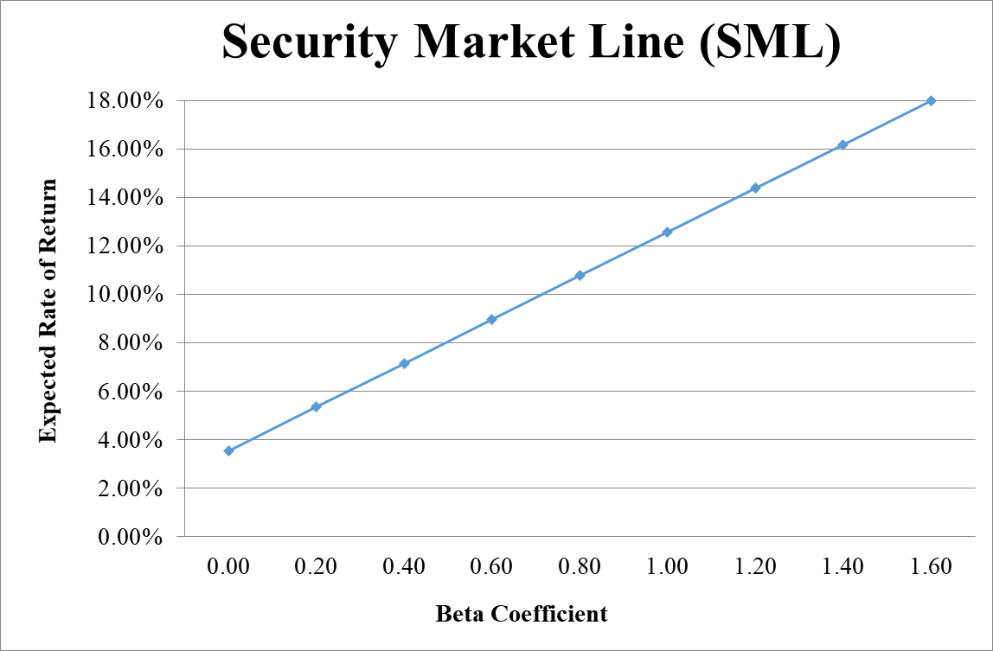
- From your plot in part c, which stocks appear to be your winners, and which ones appear to be losers? Explain the reason behind your conclusion. (2 Points)
- Logic → If Expected Return < SML Expected Return → Loser, otherwise Winner.
- Why should you consider your conclusion in part d) to be less than certain? (1 Point)
This conclusion is based on our having the right betas. Recall that calculation of Betas are subjective (i.e. depend on the market to be chosen, sample size, time interval chosen, definition of period…). If all of our betas understate their stock’s systematic risks, then we would be underestimating our portfolio risk.
GOOD LUCK!

